**Query Transactions**

Contents

Query F 2

Query H 2

Query M 3

Query C 4

Query K 5

Query G 5

Query I 6

# Query F

SELECT * from flatinspections

WHERE

Inspect_Condition = 'Unsatisfactory';

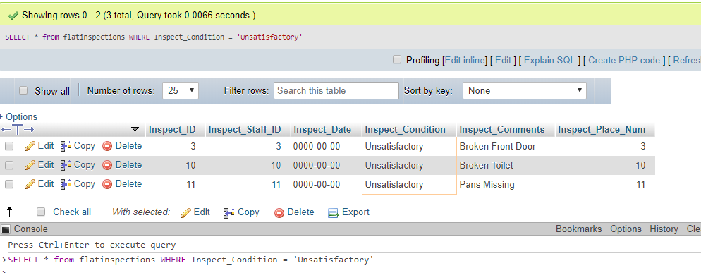

# Query H

SELECT Student_ID, Student_First_Name, Student_Second_Name FROM student

WHERE

Student_Placed = 'n';

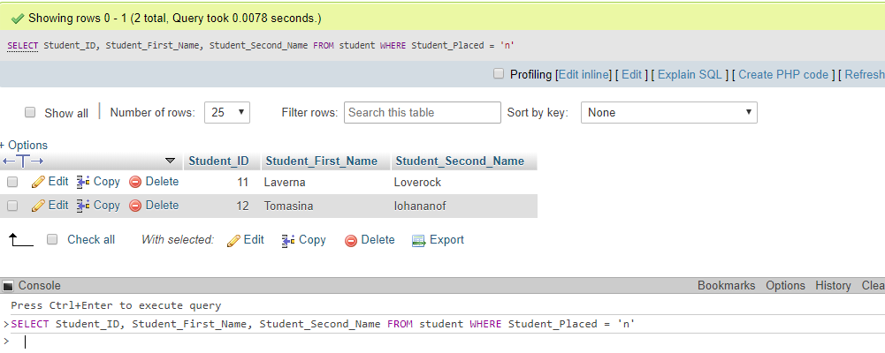

SELECT student.Student_Course_ID, course.Course_Leader, course.Course_Phone

FROM student

INNER JOIN student on student.Student_Course_ID = course.Course_ID

WHERE

student.Student_ID = 2;

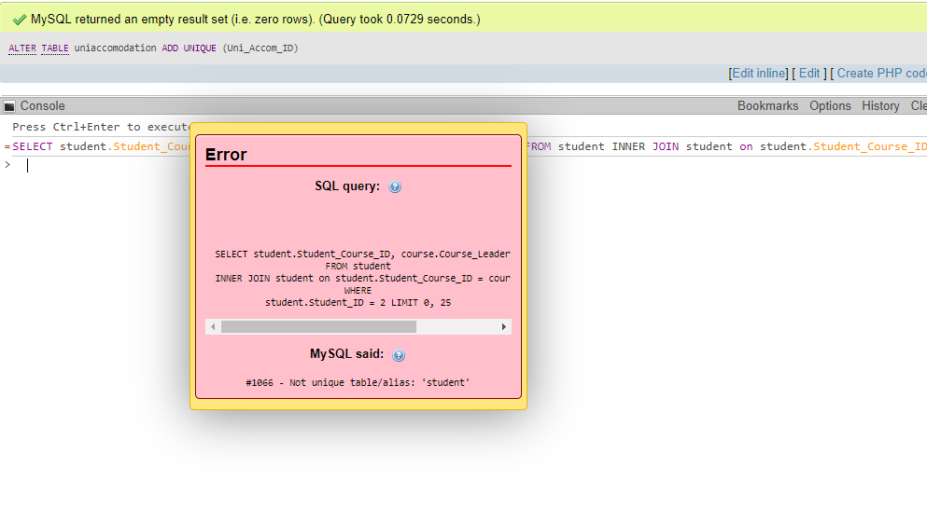

# Query M

SELECT Uni_Accom_Building_Name, Uni_Accom_Type, Uni_Accom_Num_Of_Rooms

FROM uniaccomodation

WHERE

Uni_Accom_Type = 'Halls';

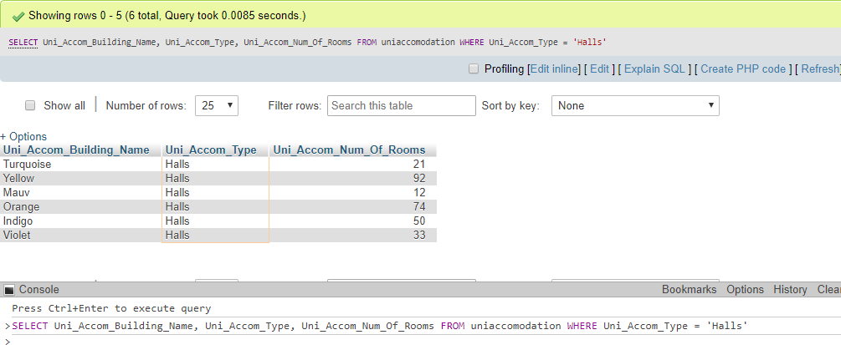

# Query C

SELECT * from lease WHERE Lease_Duration = '3'

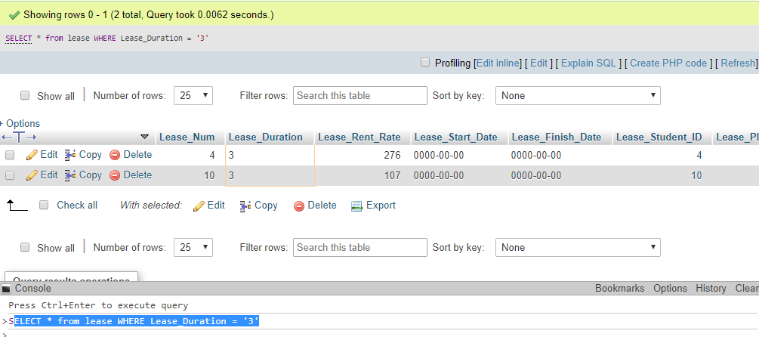

# Query K

SELECT courses.Course_Leader, courses.Course_Phone, student.Student_ID

FROM courses

INNER JOIN student ON courses.Course_ID = student.Student_Course_ID

WHERE

student.Student_ID = 2

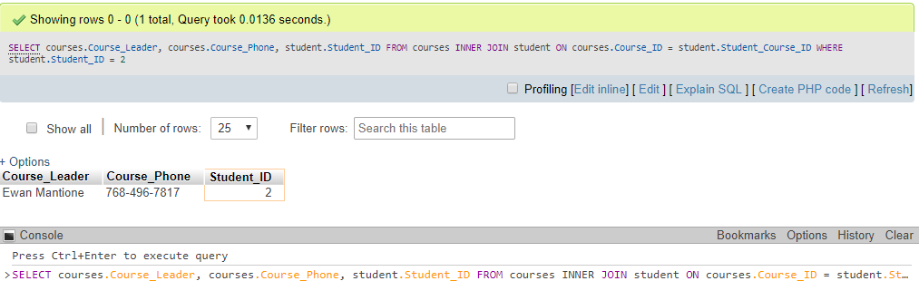

# Query G

SELECT student.Student_First_Name, student.Student_Second_Name, room.Place_Num, room.Room_Number

FROM student

INNER JOIN room ON student.Student_Place_Num = room.Place_Num;

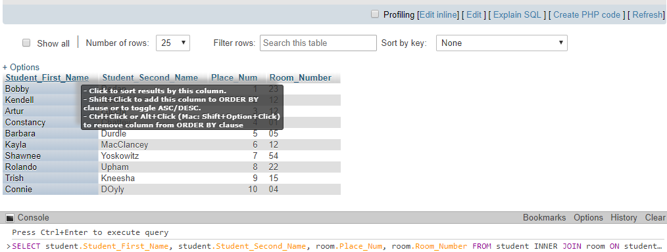

# Query I

SELECT COUNT(Student_Category), Student_Category from student

GROUP BY Student_Category;

